DIFFERENT APPLICATIONS OF THE SEIR-RAES MODEL: EXAMPLE FOR BELGIUM

1. Using the model to find the impact of your non-pharmaceutical interventions (NPI)

Given the dates on which you introduces NPI’s, you can then find the transmission rates that make the model fit the real data best. The total number of people actually in hospital, is a good measure to fit: it is both reliable (unlike tests) and rather reactive to the NPI’s (unlike the number of deaths).

Repeating this analysis for multiple countries, supplies valuable information on how (much) different NPI’s influence the transmission rate.

An example of the findings of such a fitting for Belgium

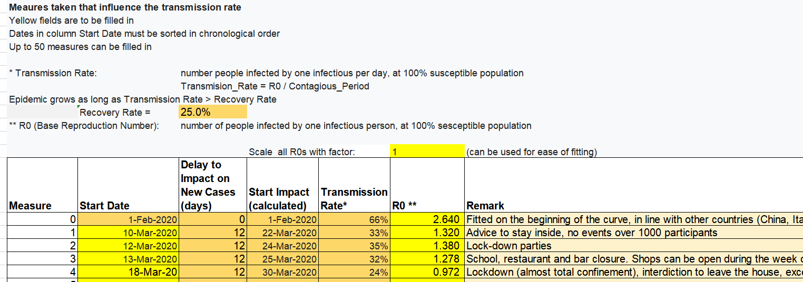

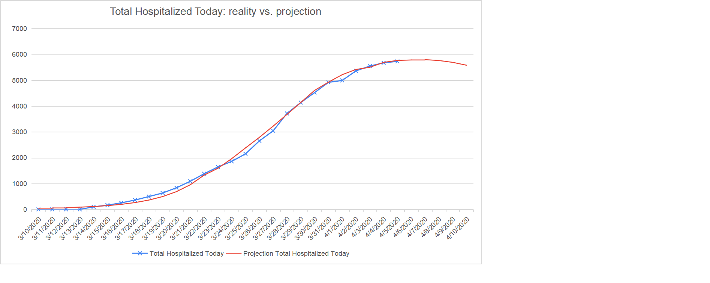

1. PROJECTION FOR HOSPITAL CAPACITY NEEDS

Once your country’s parameters are defined, you can see what hospital capacity you will need, and prepare yourself, or apply extra NPI’s to stay in the acceptable range.

An example of such a projection for Belgium

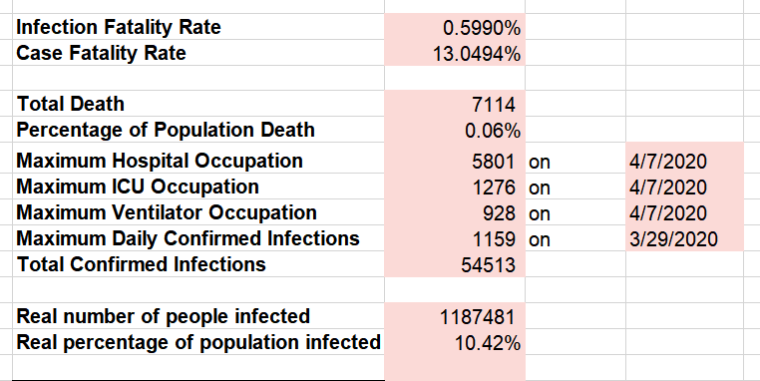

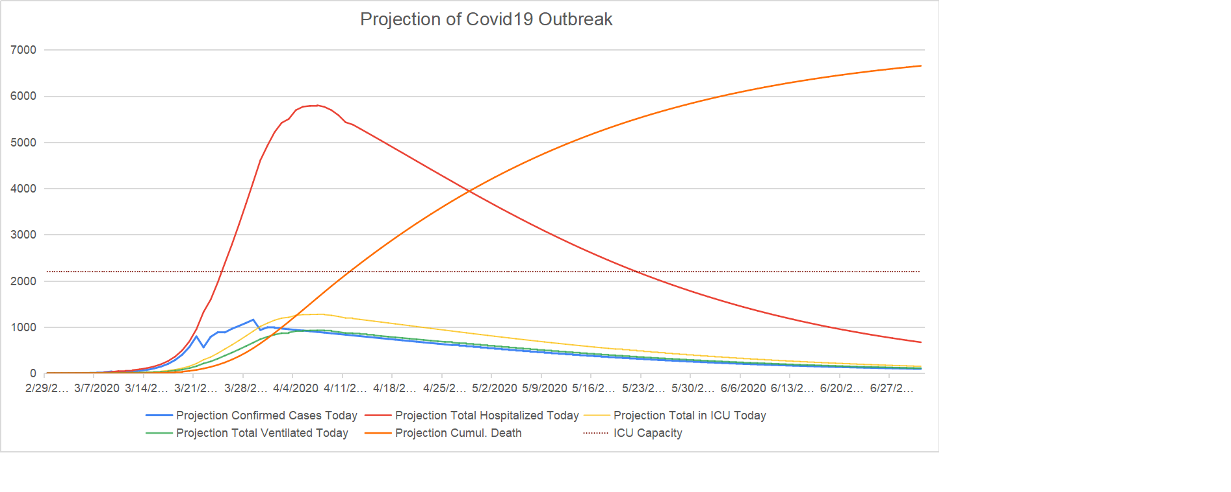

1. MONITORING THE DATA AND HANDLE IN TIME IF NECESSARY

Determine the maximum deviation your measurements can have, before you risk health care collapse in 2 weeks (the time for measures to have impact). This will allow countries to act in time.

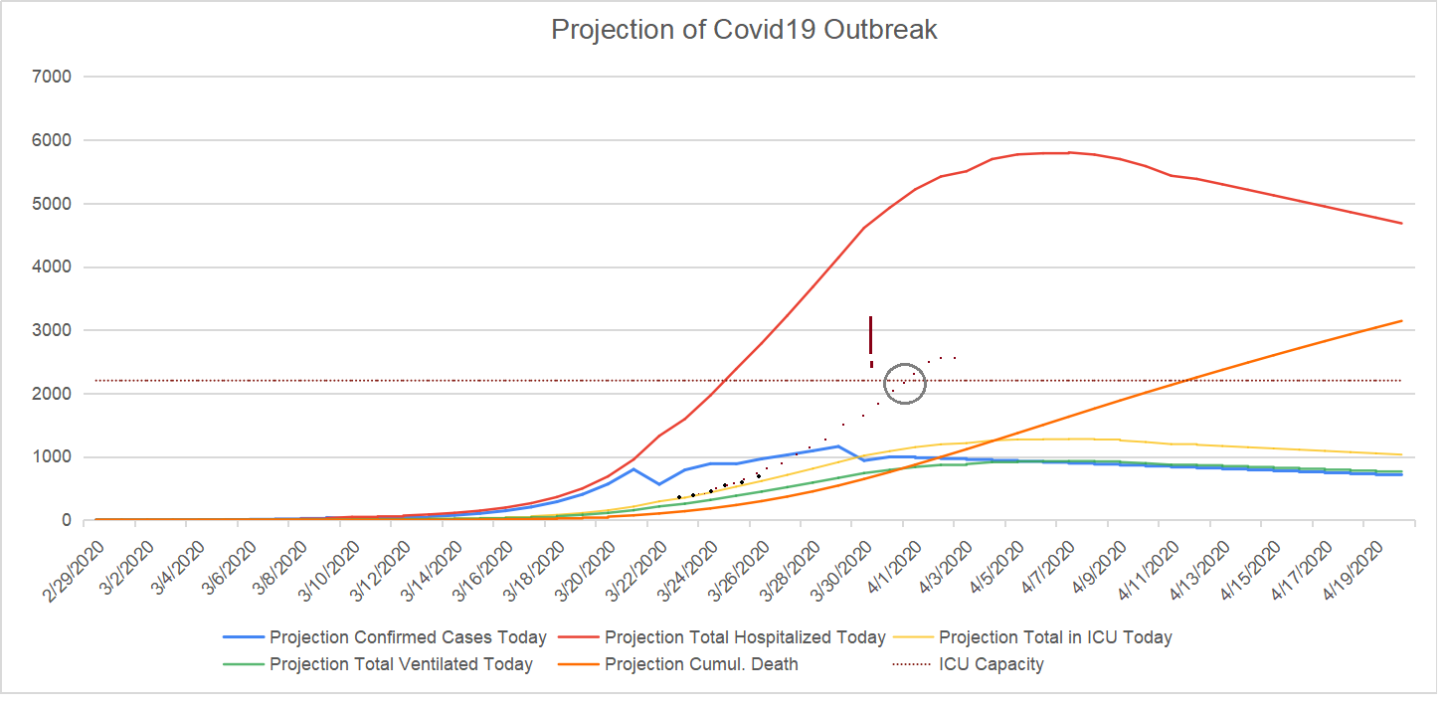

1. EXPLORE STRATEGIES FOR AFTER LOCK-DOWN

Up to 50 NPI’s can be added, and the result on the course of the epidemic can be visualized.

Some examples show what can be learned from this:

1. Lift lock-down on the first of May, replace by an interdiction on large gathering (>1000) only (transmission rate of this NPI is know from the parameter fit)

=> Lessons learned

- new spike in hospitalizations will occur

- 0.24% of the population will have died

- 40% of the population may have acquired immunity after the spike

- a ‘herd immunity’-like equilibrium will be reached, but it only applies under current NPI

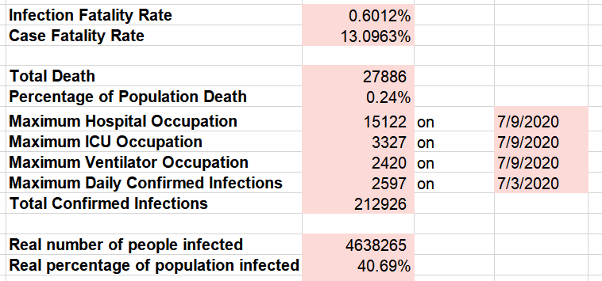

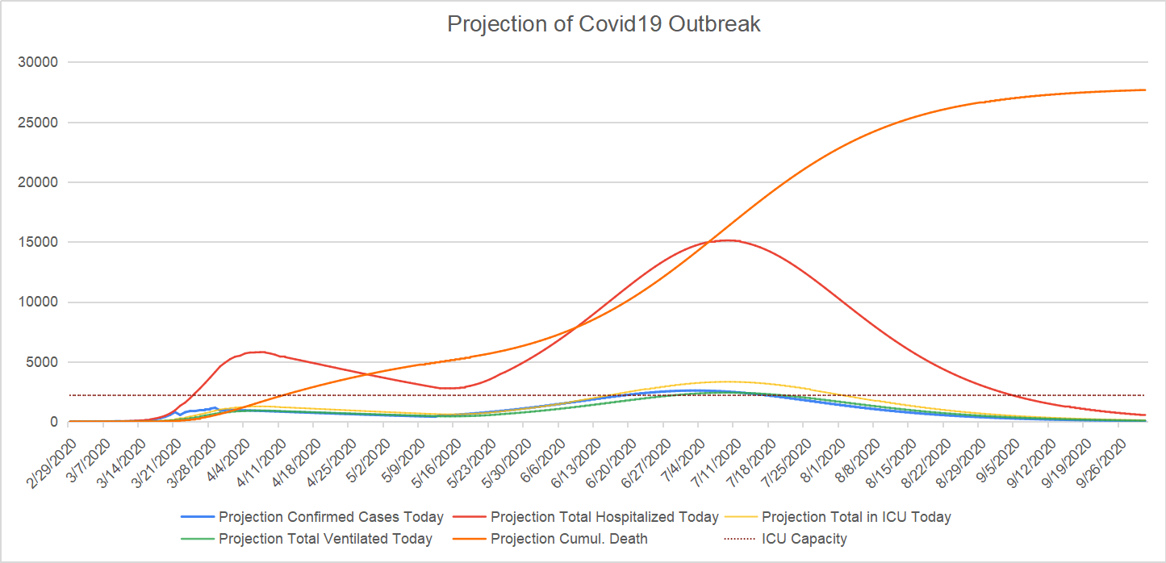

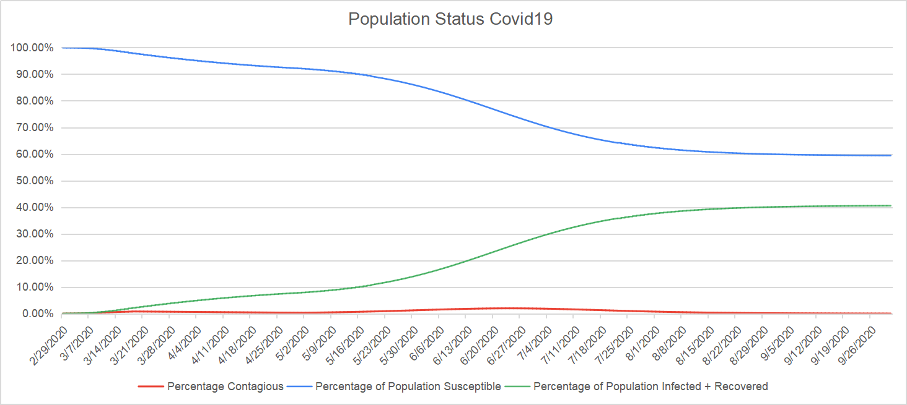

1. As in 1, and consequently lift the interdiction on large gathering on October 1st

=> Lessons learned

- another spike in hospitalizations will occur

- 0.48% of the population will have died

- 80% of the population may have acquired immunity after the spike

- true herd immunity is reached (if the virus doesn’t mutate...)

